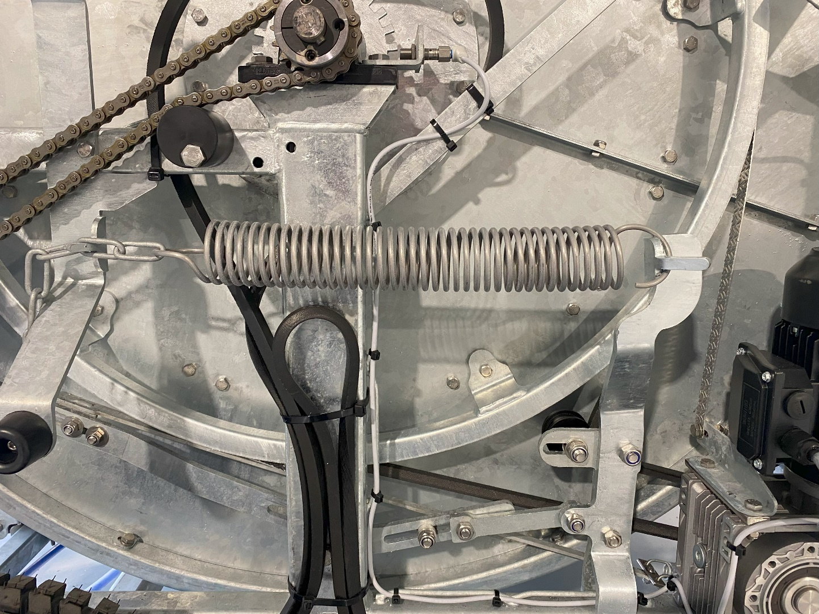
Min.1,5cm
34-37Cm

Adjustment of the spring 34-37cm

Adjustment of the tension min. 1.5cm

Startup check P 200

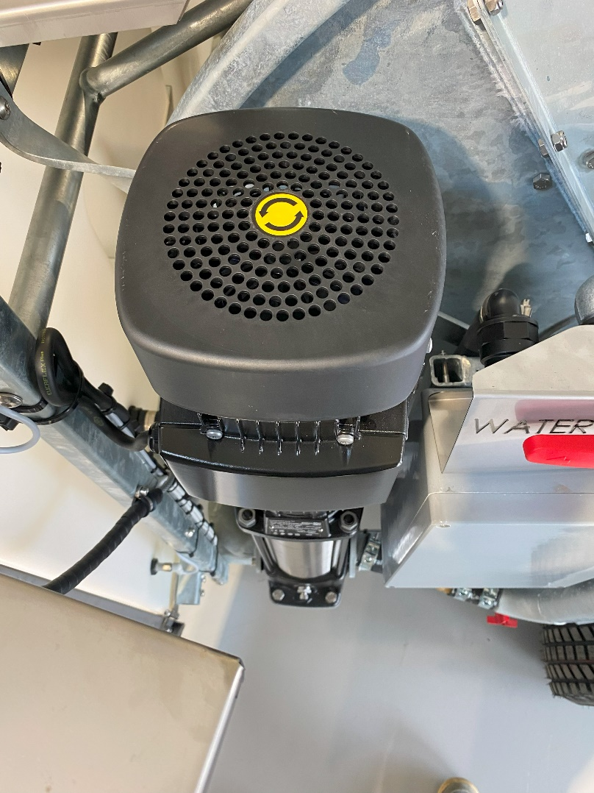
Direction on the pump!
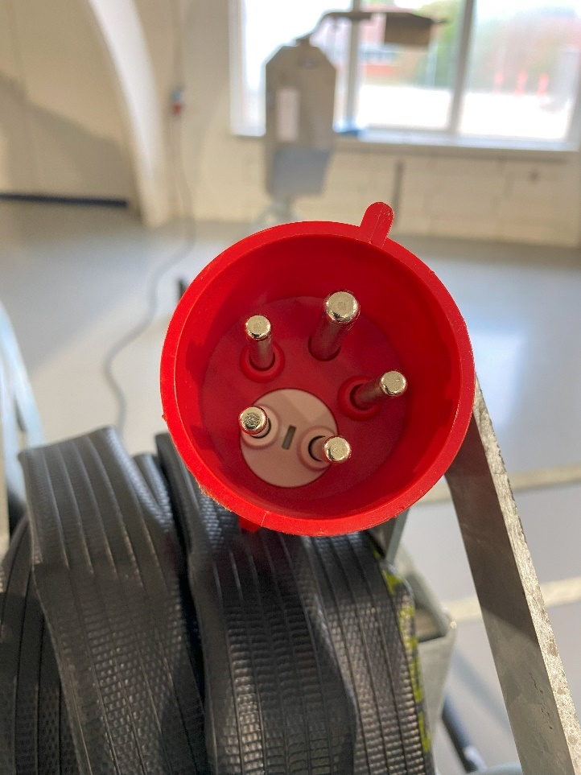
Twist to change the direction. (Phase is changed)

In the plug you can twist this to change the direction on the pump.

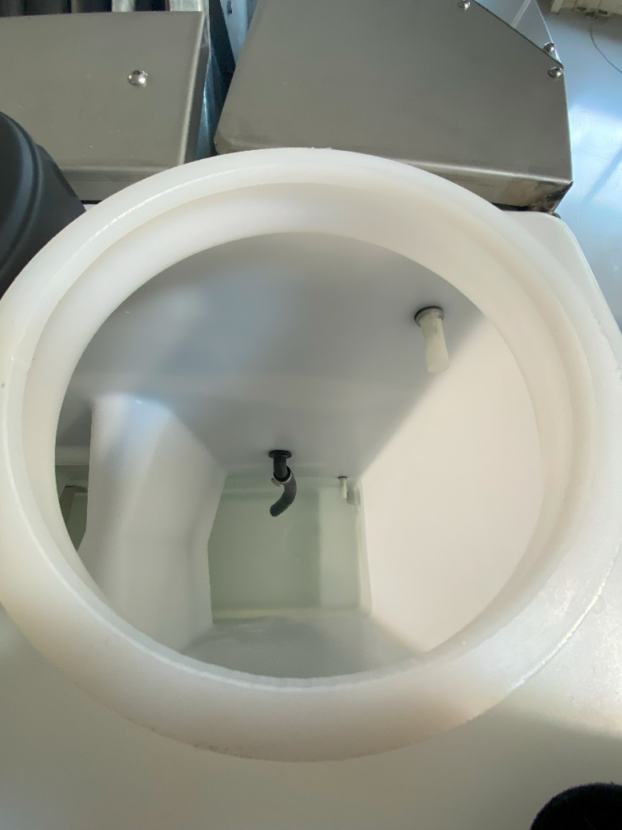
Water level sensor
Check sensor is moving free.

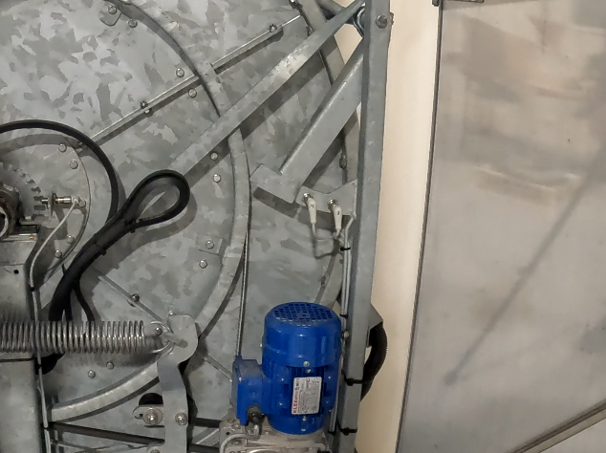
Counting sensor
Sensor for the drum hose
Sensor for the hose layer:
1 sensor layer 1 (inner sensor)
2 sensor layer 2 (booth sensor)
1 sensor layer 3 (outer sensor)
0 sensor layer 4 (no active sensor)
Counting sensor for the remaining meter hose

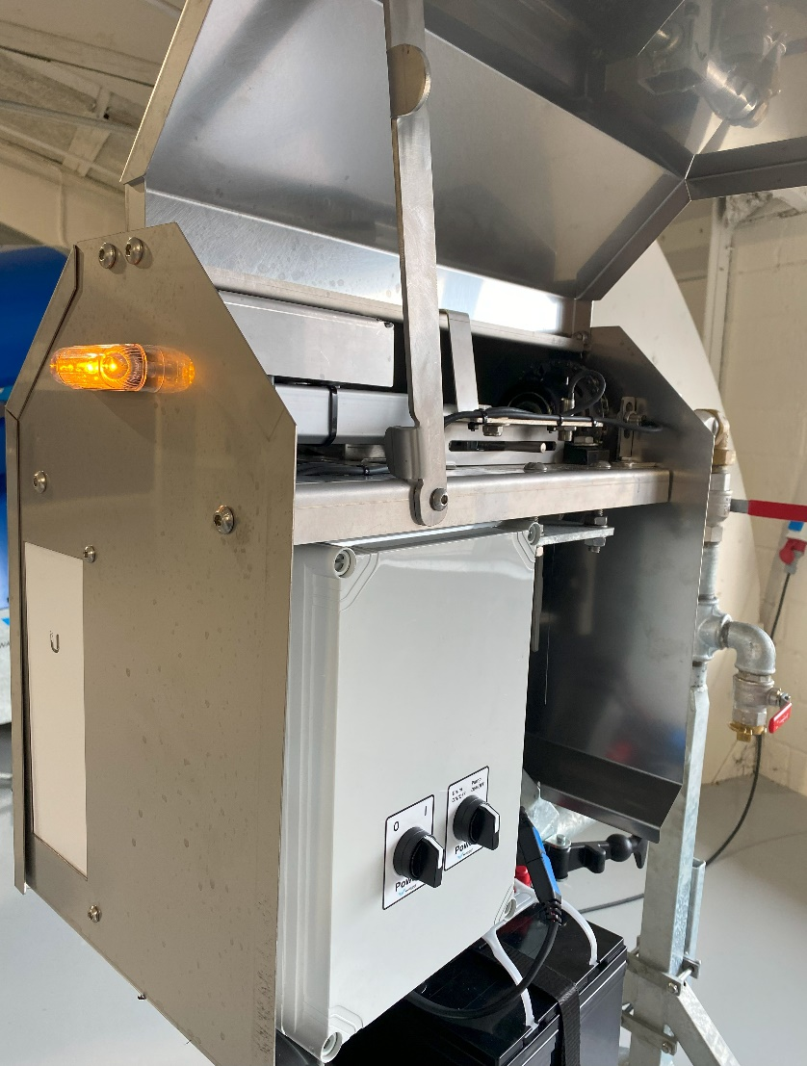
Connection light
On off button
Connection light will flash quickly in startup
Flash slowly when connected.
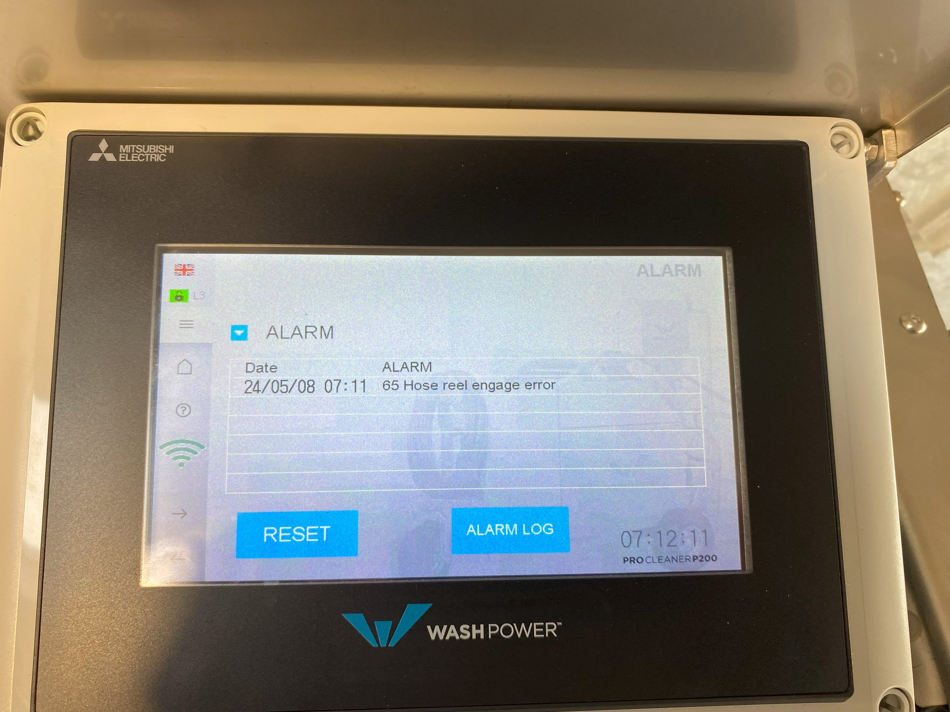
Check if there is any alarm ongoing.

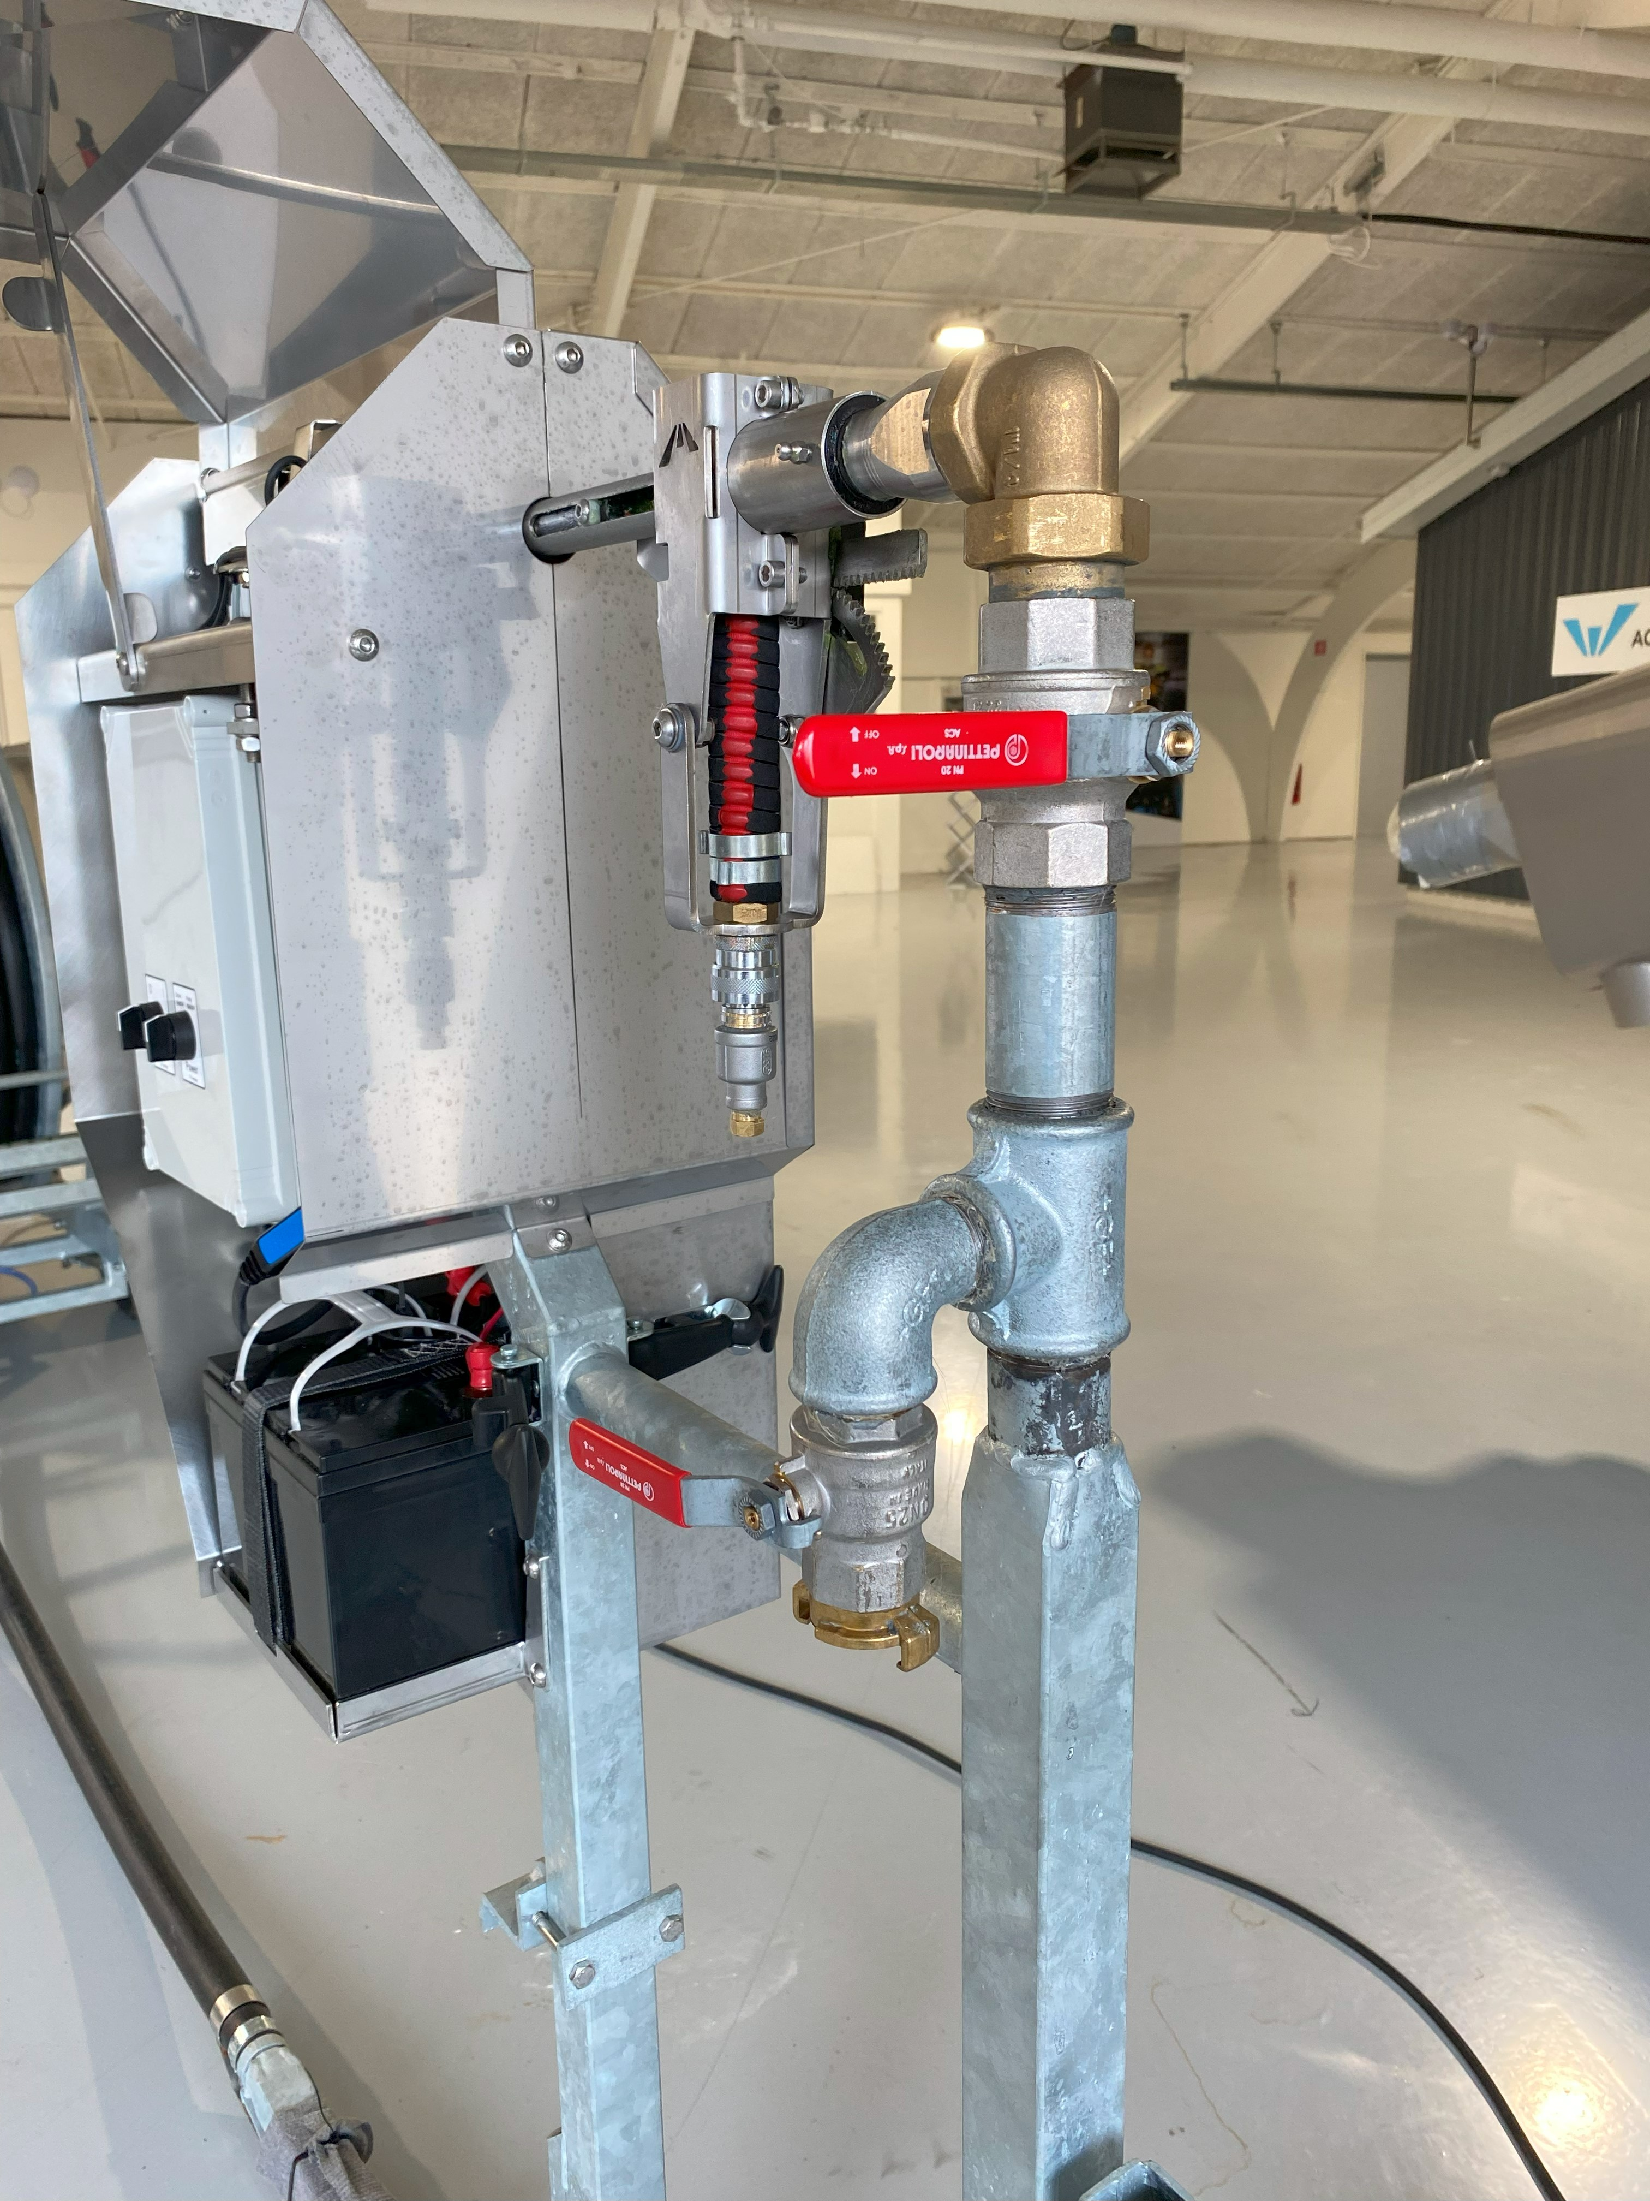
Remember to open
Remember to open the ball valve.

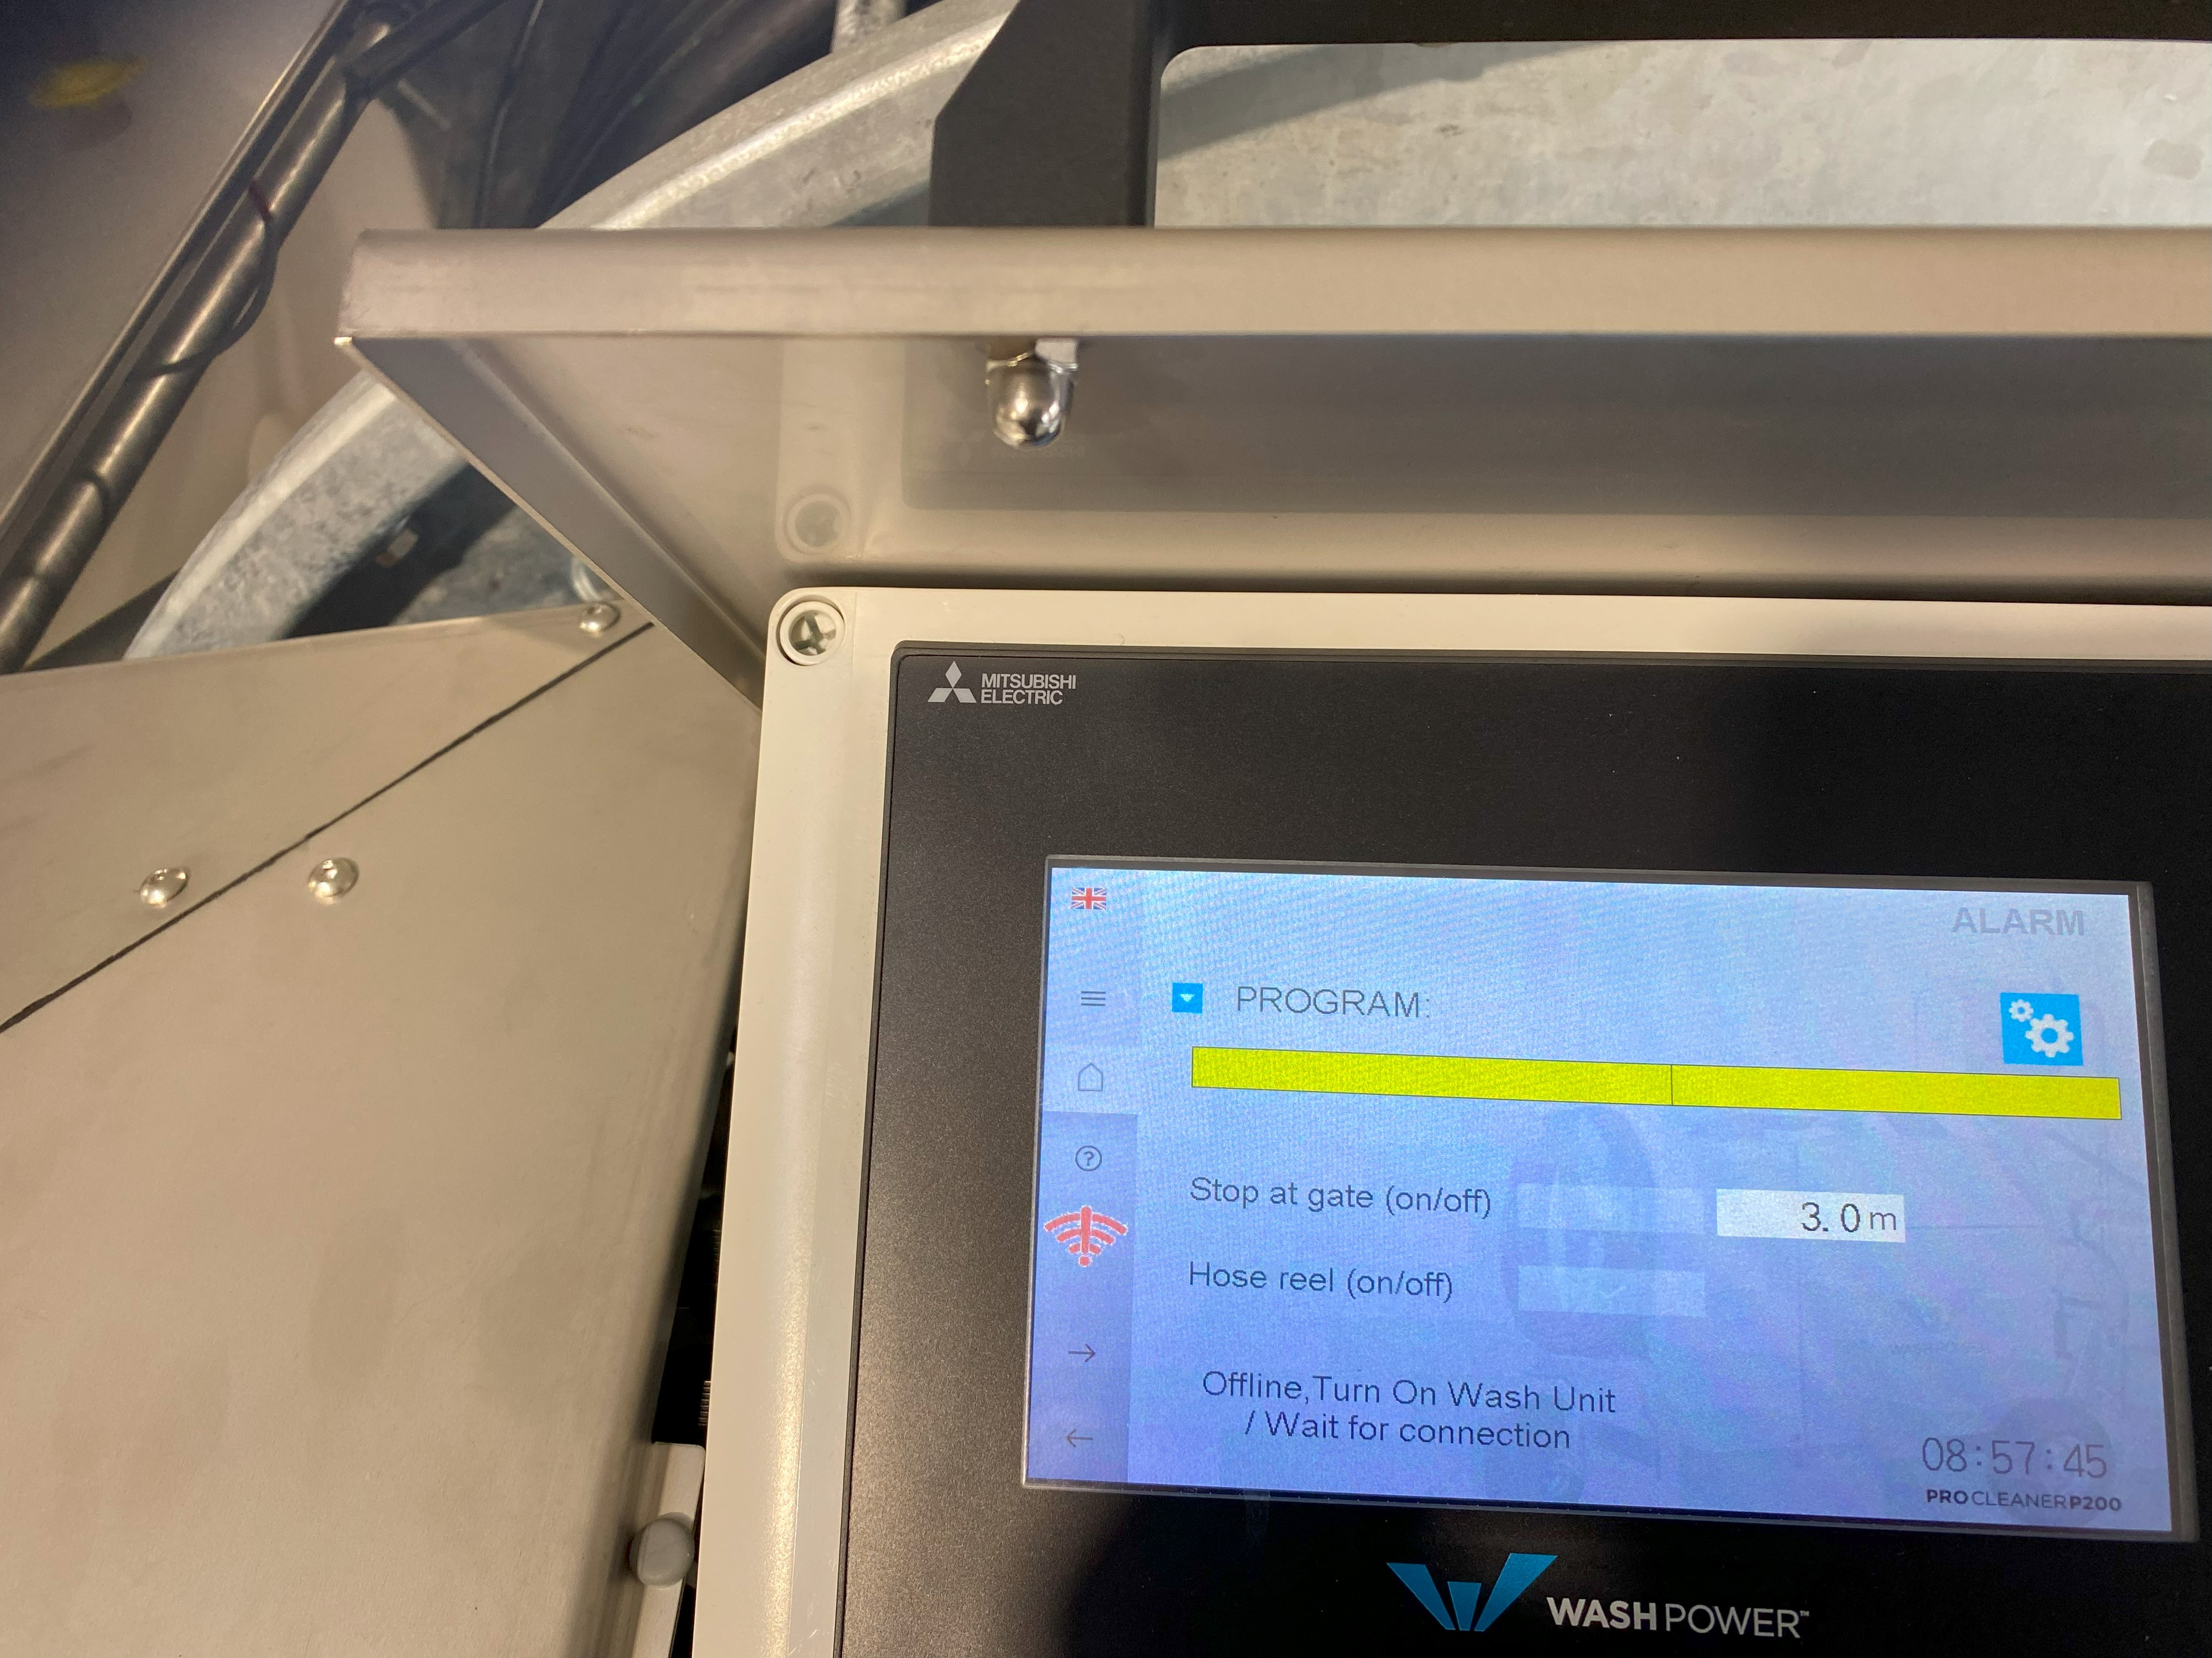
Online connect
Check Online Green is okay

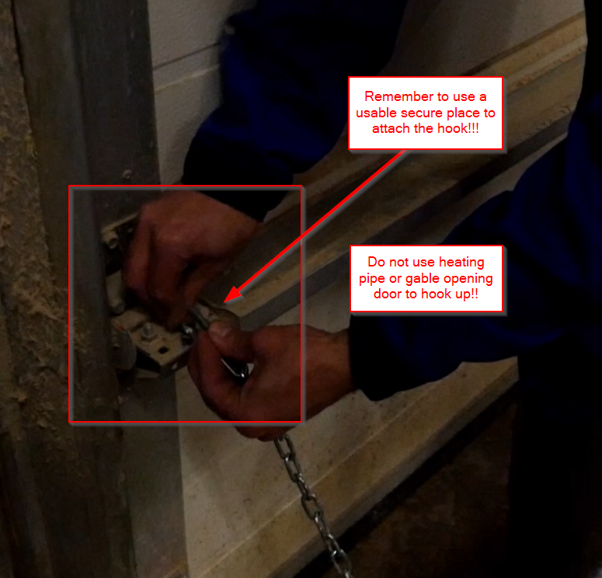
Use only secure place to hook up!!

